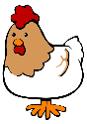

[This Photo](https://en.wikipedia.org/wiki/File:Chicken_cartoon_04.svg) by Unknown Author is licensed under [CC BY-SA](https://creativecommons.org/licenses/by-sa/3.0/)